BLAS DYFI TASTE Charter

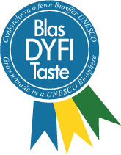

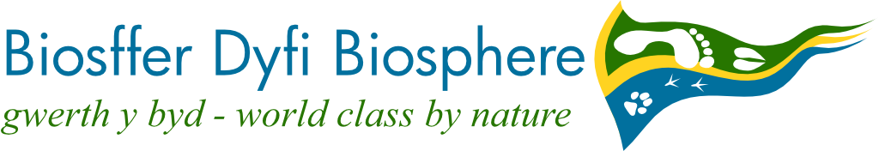

_____________________________________ promotes fresh and seasonal produce grown, reared or made in the Dyfi Biosphere area, and agrees with the Dyfi Biosphere's vision:

»The Dyfi Biosphere will be recognised and respected internationally, nationally and locally for the diversity of its natural beauty, heritage and wildlife, and for its people’s efforts to make a positive contribution to a more sustainable world. It will be a self confident, healthy, caring and bilingual community, supported by a strong locally-based economy.«

Our use of the Blas Dyfi Taste brand makes us part of a network that supports the local food economy, increases awareness of locally grown produce, supports primary and secondary food producers and provides a good food destination for visitors.

We meet the ‘criteria for participation’ overleaf and will promote the brand as well as the food and drink.

To make our business and the area more sustainable, we will take the following actions:

We will review progress and sign the Charter again within three years, which is when our permission to use the logo on premises, packaging and promotional material lapses.

Name and signature on behalf of Business/Group:  _____________________________ | Date:____________
Name and signature on behalf of the UNESCO Dyfi Biosphere:

_____________________________

