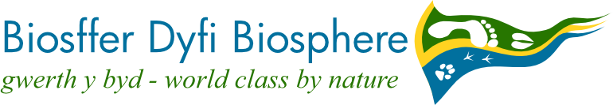
c/o Y Plas

Machynlleth

SY20 8ER

01654 703965

PRESS RELEASE

21/02/2018

Education in the Dyfi Biosphere gets a boost

Following the recent announcement that Ysgol Bro Hyddgen in Machynlleth has won an UNESCO award based in part on its work with the Dyfi Biosphere, the Dyfi Biosphere Partnership has started a six-month project to create new opportunities for young people to envision a sustainable future for the area. This will build on the work done by members of the Dyfi Biosphere Education Group since 2010.

A local consultant, Jane Powell, has been appointed to work with the Education Group and others - to find new ways to engage young people in discussions about energy, food, jobs and culture in the region, which was given UNESCO Biosphere status in 2009.

The Biosphere includes not only the Dyfi Valley but also Borth and Aberystwyth, and is known for its natural beauty and wildlife, attracting visitors from all over the world.

Currently the Education Group includes the RSPB at Ynys-hir, the Centre for Alternative Technology, the Montgomeryshire Wildlife Trust’s Dyfi Osprey Project, Dyfi Woodlands, Farming and Countryside Education and the Natural Resources Wales reserve at Ynyslas, but other education providers are invited to join in.

“The Dyfi Biosphere is internationally recognized for the quality of its landscape, culture and environment, but unfortunately many young people move away because it can be hard to find jobs,” said Jane. “We want to involve local residents in shaping the future of the area, and we want to share our learning with the rest of Wales”.
The work will be supported by the Rural Development Programme Local Action Groups for Ceredigion, Powys and Gwynedd and by ecodyfi. This project has received funding through the Welsh Government Rural Communities – Rural Development Programme 2014-2020, which is funded by the European Agricultural Fund for Rural Development and the Welsh Government.

Jane, who will be working on this until July, is keen to hear from anyone with ideas for developing educational activities in the area, whether for schools or the community generally. She can be contacted via the Dyfi Biosphere on 01654 703965, through www.dyfibiosphere.wales or info@ecodyfi.org.uk.

Press enquiries: Andy Rowland; 01654 703965

Image:
Year 8 pupils exploring a map of the Dyfi Biosphere

Notes to editors:
- A UNESCO Biosphere is an area in which people work to balance the conservation of biodiversity with its sustainable use. They inspire communities to work together in creating a sustainable future we can all be proud of, connecting people with nature and cultural heritage, while strengthening local economies.
- Since 2009, the Dyfi Biosphere has covered Aberystwyth and the Dyfi Valley.
- The development project is funded by the Welsh Government and the EU as part of the Rural Development Programme. It is a collaboration between the Local Action Groups of Ceredigion, Powys and Gwynedd, that are called Cynnal y Cardi, Arwain and Arloesi Gwynedd Wledig, respectively. LEADER aims to improve the quality of life in rural areas by applying a very specific method of working, which includes the engagement, capacity building, participation and mentoring of individuals, businesses, community and voluntary groups. It looks to engage grass roots communities to encourage the generation of innovative ways to sustain the rural economy through investigating, trialling and piloting activity. http://www.cynnalycardi.org.uk/english/?page_id=2530
